User requirements System

7G wines

Mihail Kenarov,

FONTYS HOGESCHOOLEN

20 feb 2023

# Hartingsveldt,Stan S. Van, Marcel Boelaars,Jesús Ravelo

# 

Table of contents

Table of contents 1

Version control 2

Agreements with clients: 3

Functional Requirements: 3

MoSCoW 3

Must have: 4

Should have: 4

Could have: 4

Won’t have: 4

Use cases 4

GUI 5

Website wireframe 6

Homepage 6

Wines 7

Events 8

Blog 9

About us 10

Contacts 11

Gifts 12

Accessories 13

# Version control

|  |  |  |
| --- | --- | --- |
| Version | Date | Changes |
| 0.1 | 20 feb 2023 | Initial document version |

# Agreements with clients:

We must deliver an intermediate version on Friday week 3 which contains:

* Wine management (desktop app)
  + Create
  + Read
  + Update
  + Delete
  + Stored data (Name, Price, Amount, Classification, Originates from)
* Collections management (desktop app)
  + Create
  + Read
  + Update
  + Delete
  + Stored data (Name, Price, Amount, Contains, Occasion)
* Filters for wines (Website app)
* Price
* Classification
* Originates from
* Filter for collections (Website app)
* Price
* Occasion

# Functional Requirements:

The admin can create, delete, update or read data about the wines in their shop and these changes should be visible to the visitors of the website. The same principle is applied when it comes to the implementation of the collection. While using the web application the customer will be able to filter the wines or collections, based on the different properties of the products.

# MoSCoW

## Must have:

* FR-01: Wine management (desktop app)
* FR-02: Collections management (desktop app)

## Should have:

* FR-03: Filter for the wines (web app)
* FR-04: Filter for the collections (web app)

## Could have:

## Won’t have:

* “Sneak peek” of what wines might be added in the future.

# Use cases

|  |  |
| --- | --- |
| **UC-01** | **Creating wines (FR-01)** |
| **Actor** | **Admin** |
| **Pre - condition** | **Actor must be in the desktop application** |
| **MSS** | 1. **Actor enters the required data for the wine.** 2. **System adds the new wine to a database** |
| **Extension(s)** | 2a. Actor did not fill the data required to add the wine.   1. System displays that data is missing. 2. Return to MSS 1   2b. Actor mistakenly duplicates data.   1. System displays that the wine already exists. 2. Return to MSS 1 |

|  |  |
| --- | --- |
| **UC-02** | **Deleting wines (FR-01)** |
| **Actor** | **Admin** |
| **Pre- condition** | **Actor must be in the desktop application** |
| **MSS** | 1. **Actor selects the wine that they want to delete.** 2. **System deletes the wine from the database** |
| **Extension(s)** | 1a. Actor did not select a wine to delete.   1. Show a message that they need to select the wines. 2. Return to MSS 1 |

|  |  |
| --- | --- |
| **UC-03** | **Updating wine’s data (FR-01)** |
| **Actor** | **Admin** |
| **Pre - condition** | **Actor must be in the desktop application** |
| **MSS** | 1. **Actor selects the wine that they want to u**pdate. 2. **System s**hows the information about the wine. 3. **Actor updates the data about the selected item.** 4. **System updates the information about the selected wine.** |
| **Extensions** | **3a. Actor did not update the data about a wine.**   1. **System shows a message saying that the data has not been changed.**   **2. return to MSS 1** |

|  |  |
| --- | --- |
| **UC-04** | **Creating collection (FR-02)** |
| **Actor** | **Admin** |
| **Pre- condition** | **Actor must be in the desktop application** |
| **MSS** | 1. **Actor enters the required data for the collection.** 2. **System adds the new collection to a database** |
| **Extension(s)** | 1a. Actor did not fill the data required to add the collection.   1. System displays that data is missing. 2. Return to MSS 1   1b. Actor mistakenly duplicates data.   1. System displays that the collection already exists. 2. Return to MSS 1 |

|  |  |
| --- | --- |
| **UC-05** | **Deleting Collections (FR-02)** |
| **Actor** | **Admin** |
| **Pre- condition** | **Actor must be in the desktop application** |
| **MSS** | 1. **Actor selects the wine that they want to delete.** 2. **System deletes the wine from the database** |
| **Extension(s)** | 1a. Actor did not select a wine to delete.   1. Show a message that they need to select the wines. 2. Return to MSS 1 |

|  |  |
| --- | --- |
| **UC-06** | **Updating a collection’s data (FR-02)** |
| **Actor** | **Admin** |
| **Pre- condition** | **Actor must be in the desktop application** |
| **MSS** | 1. **Actor selects the c**ollection item **that they want to u**pdate. 2. **System s**hows the information about the selected collection. 3. **Actor updates the data about the selected it.** 4. **System updates the information about the collection.** |
| **Extensions** | **3a. Actor did not update the data about a Collection.**   1. **System shows a message saying that the data has not been changed.** 2. **2. return to MSS 1** |

|  |  |
| --- | --- |
| **UC-07** | **Filtering wines (FR-03)** |
| **Actor** | **Customer** |
| **Pre- condition** | **Actor must be in the web application** |
| **MSS** | 1. **Actor enters the page for the wines.** 2. **System shows the possible products.** 3. **Actor filters the items by a given characteristic.** 4. **System** **rearranges** **the wines, by the given filter** |
| **Extension(s)** | 3a. Actor did not select given filter.   1. Actor is seeing the page as it was. 2. Return to MSS 3   4a. System does not rearrange the wines.  1a. Actor should refresh the page.  2a. Return to MSS 3  4a. System does not rearrange the wines.  1b. Actor should refresh use the contact form for a complaint.  2b. Return to MSS 3 |

|  |  |
| --- | --- |
| **UC-08** | **Filtering wines (FR-04)** |
| **Actor** | **Customer** |
| **Pre- condition** | **Actor must be in the web application** |
| **MSS** | 1. **Actor enters the page for the collection.** 2. **System shows the possible products.** 3. **Actor filters the items by a given characteristic.** 4. **System** **rearranges** **the collections, by the given filter** |
| **Extension(s)** | 3a. Actor did not select given filter.   1. Actor is seeing the page as it was. 2. Return to MSS 3   4a. System does not rearrange the collection.  1a. Actor should refresh the page.  2a. Return to MSS 3  4a. System does not rearrange the collection.  1b. Actor should refresh use the contact form for a complaint.  2b. Return to MSS 3 |

# GUI

This is the main administration menu and from it the admin will be able to create a simple product, the wines and the collections, while also having the possibility to check previous products and the information about them

When the admin enters this tab they are able to edit the data of a see the items, select whichever one they would like and edit it’s data.

# Website wireframe

## Homepage

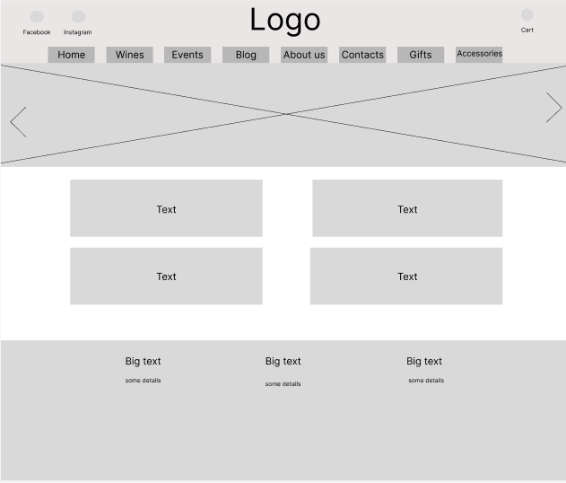

The customers should be greeted by homepage which contains a small number of pictures, text and the logo, that will get them familiar with the shop. There will be a header, which contains a menu, that helps them go to the other pages of the website.

## Wines

Here the customers can see the different wines that are offered and also the filters that can be used to help them go through the lists of wine

## Events

This is where the customers can see information about events which the shop has organized throughout the past.

## Blog

This is a small blog page, where the admin can talks about different topics, surrounding the wines, which might interest the customers more, when it comes to “the wine culture” itself.

## About us

In this page there will be photos which show how the shop looks, where it is, what it is about and how it came to be.

## Contacts

This page will have the information which may be needed to contact the shop and has a feedback forum, where they can send some complains that they have or questions that they want to ask.

## Gifts/Collections

Here the customers can see the different collections that are possible to order and the details about the. The site will also be having a filter.

## Accessories

This is a page for different products/accessories which the customer can filter.